AWS Web Application Firewall (WAF)
AWS WAF (Web Application Firewall) is a security service that helps protect web applications from common web attacks by monitoring and filtering HTTP and HTTPS requests.
It allows you to create rules to allow, block, or monitor incoming web requests before they reach your application.

How AWS WAF Works
- A user sends an HTTP/HTTPS request.
- AWS WAF inspects the request.
- WAF compares the request against its rules.
- Based on the rules, WAF:
  - Allows the request
  - Blocks the request
  - Counts the request for monitoring
- The allowed request reaches your application.

Objective
Create an AWS WAF Web ACL, associate it with an Application Load Balancer (ALB), configure rules to protect a web application, and verify that the rules work.

Architecture
Internet Users
|
↓
AWS WAF
|
↓
Application Load Balancer
|
↓
EC2 Web Server

Prerequisites
- AWS account
- One running EC2 instance with a web server (Apache or Nginx)
- An Application Load Balancer (ALB) forwarding traffic to the EC2 instance
- A browser or Postman for testing

Step 1: Create an EC2 Web Server
- Launch an EC2 instance.
- Install Apache or Nginx.
- Verify the website opens using the ALB DNS name.
Example: http://my-alb-123456.ap-south-1.elb.amazonaws.com

Step 2: Open AWS WAF
- Sign in to the AWS Management Console.
- Search for WAF & Shield.
- Open AWS WAF.
- Click Create web ACL.

Step 3: Configure the Web ACL
Enter:
Name:
demo-web-acl
Choose the region where your ALB is deployed.
For Resource type, select:
Regional resources

AWS Web Application Firewall (WAF)
AWS Systems Manager Parameter Store
AWS Systems Manager Parameter Store is a service that allows you to securely store, organize, and retrieve configuration data and secrets for your applications and AWS resources.
It is commonly used to store:
- Database connection strings
- API URLs
- Application configuration values
- Environment variables
- Passwords (as encrypted Secure String parameters)
- License keys
Unlike AWS Secrets Manager, Parameter Store is primarily designed for configuration management, although it can also store sensitive values securely.

Objective
Create parameters in AWS Systems Manager Parameter Store, retrieve them through the AWS Console and AWS CLI, and optionally access them using a Python application.

Architecture
Application
|
| Get Parameter
↓
AWS Systems Manager
Parameter Store
|
↓
Configuration Data

Prerequisites
- AWS Account
- IAM user with Systems Manager permissions
- AWS CLI configured (optional)
- Python installed (optional)

Step 1: Open Parameter Store
From the left menu:
Application Management
↓
Parameter Store
Click: Create parameter
Field | Value
Name | /dev/database/username
Description | Database Username
Tier | Standard
Type | String
Value | admin
Click Create parameter.
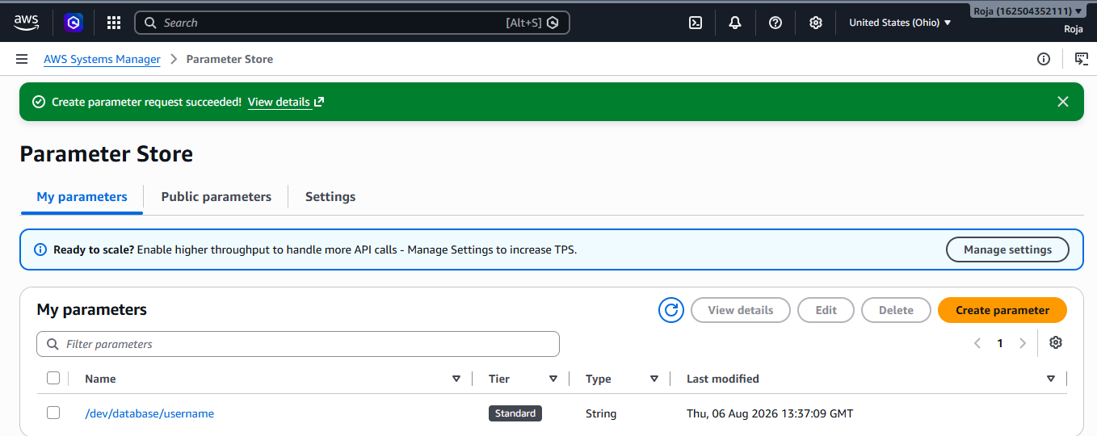

Step 2: Create a Secure Parameter
Click Create parameter again.
Configure:
Field | Value
Name | /dev/database/password
Description | Database Password
Tier | Standard
Type | SecureString
KMS Key | AWS managed key (default)
Value | MySecurePassword123
Click Create parameter.

Step 3: View Parameters
In Parameter Store, you should see:
/dev/database/username
/dev/database/password
Select a parameter to view its details.
For SecureString, the value is encrypted. You need appropriate IAM permissions to decrypt and view it.

Step 4: Retrieve Parameters Using Python
Install the AWS SDK: pip install boto3
Create: get_parameter.py
Code:
import boto3

ssm = boto3.client("ssm", region_name="ap-south-1")

response = ssm.get_parameter(
Name="/dev/database/password",
WithDecryption=True
)

print("Password:", response["Parameter"]["Value"])
Run:
python get_parameter.py
Output:
Password: MySecurePassword123

Step 5: Test IAM Permissions
If you remove the following IAM permissions:
- ssm:GetParameter
- kms:Decrypt (for SecureString)
the application or CLI won't be able to retrieve the parameter.
This demonstrates how IAM protects access to Parameter Store.

AWS Web Application Firewall (WAF) & AWS Systems
Manager Parameter Store
AWS Web Application Firewall (AWS WAF)
AWS Web Application Firewall (AWS WAF) is a security service that protects your web
applications from common web attacks such as SQL Injection, Cross-Site Scripting (XSS),
bots, and DDoS-related HTTP floods by filtering and monitoring incoming HTTP/HTTPS
requests.
Think of AWS WAF as a security guard standing at the entrance of your website.
• Legitimate users → Allowed in
• Attackers → Blocked
• Suspicious users → Challenged (CAPTCHA)
Why do we need AWS WAF?
Suppose you have an e-commerce website.
https://shop.com
Thousands of users visit your site every day.
Among them:
• Genuine customers
• Hackers trying SQL Injection
• Bots trying to log in with stolen passwords
• Users sending malicious scripts
Without WAF:
Internet
|
|
Website (Directly exposed)
The website has to handle every request, including malicious ones.
With AWS WAF
Internet
|
AWS WAF
|
Application Load Balancer
|
EC2 / ECS / Lambda
Every request first goes through AWS WAF.
WAF checks:
• Is this request safe?
• Does it match any attack pattern?
• Is the IP blocked?
• Is the request rate too high?
If safe:
Allow
Otherwise:
Block
SQL Injection Attack
Imagine your website has a login page.
Username: Password:
A hacker enters:
' OR 1=1 --
Instead of:
Swetha
The request becomes
POST /login
username=' OR 1=1 --
password=test
AWS WAF detects this SQL Injection pattern.
Result:
Request → BLOCKED
Your application never receives it.
Cross-Site Scripting (XSS)
A comment box accepts user input.
Normal user:
Nice product!
Attacker submits:
<script>alert("Hacked")</script>
AWS WAF recognizes this malicious script.
BLOCK
The script never reaches your application.
Bot Protection
A bot tries to log in 5,000 times in one minute.
192.168.x.x
Login
Login
Login
Login
Login
...
5000 requests
AWS WAF Rate-Based Rule:
Limit = 100 requests per 5 minutes
Result:
IP blocked

